Why Cell-Based Architecture the best way to reduce blast radius?

* Workload isolation
* Failure containment
* Testability
* Manageability

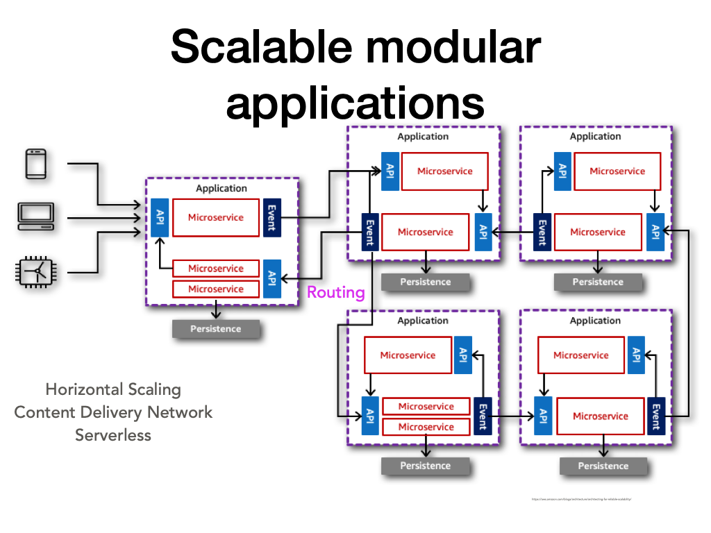

Identify KPIs for your project

In the context of AWS support, why must an EC2 instance be unreachable for 20 minutes rather than allowing customers to open tickets immediately?

A. Because most reachability issues are resolved by automated processes in less than 20 minutes

B. Because all EC2 instances are unreachable for 20 minutes every day when AWS does routine maintenance

C. Because all EC2 instances are unreachable for 20 minutes when first launched

D. Because of all the reasons listed here

Answer: A

Explanation: An EC2 instance must be unreachable for 20 minutes before opening a ticket, because most reachability issues are resolved by automated processes in less than 20 minutes and will not require any action on the part of the customer. If the instance is still unreachable after this time frame has passed, then you should open a case with support.

Reference: <https://aws.amazon.com/premiumsupport/faqs/>